  - School of Engineering, Computing and Mathematics
  - Oxford Brookes University
  - COMPT5047: Applied Software Engineering
  - (Semester 1, 2025-2026)

  - Section 1: Project Management (20 Marks)

Subsystems
- USU Student App
- Student Union Management System
- USU Operation System
- Society Leader App

Chosen Subsystem: Student Union Management System

Section 2: Analysis and Specify Software Quality Requirements (20 Marks)

Functional Requirement – “Create Events”

Introduction

Within this section, I will analyse and specify quality requirements based on the chosen functional requirement for my subsystem. These requirements are placed into four specific attributes: Performance, Reliability, Scalability, Security and Privacy Protection. By using these Attributes, I can ensure that this system will deliver an appropriate and impressive system for the user experience for all society leaders. The following requirements for each attribute are:

Performance
- The system must handle a large number of register requests or ticket buys for each society event to allow a good experience for society members.
- The system should be able to update society event information immediately after being refreshed and be able to trigger notifications with this creation.
- Must be able to hold vast amounts of info without crashing or buffering.

Reliability
- All data must be saved atomically, and no records can be partial or corrupted if a failure were to occur.
- Event data that is being created in a draft will be autosaved every 30 seconds to prevent work from being lost due to any accidental disconnections.
- The service, allowing the creation of events, should be up more than 98% of the time to not get in the way of society leaders and allow a reliable environment.

Scalability
- Allowing the system to run and scale horizontally with multiple subsystems running concurrently to ensure a smooth workflow as the number of users increases.
- Responsiveness should be maintained acceptable especially at peak periods, to allow for a good workflow for society leaders and society members.
- Optimised database queries should be implemented to stop bottlenecking as the records scale.

Security and Privacy protection
- Access to privileged controls will be based on roles. This means society leaders will only be permitted to access the event creation interface.
- All fields of an event creation submission will be rigorously tested using server-side validation to prevent attacks from cyber threats.
- Data isolation must be used to ensure the prevention of cross-society data access for society leaders when creating new events.

Section 3: Specification and Modelling Software Functional Requirements (20 Marks)

Diagrams
These are the diagrams to show how ‘Create Events’ is modelled within the Student Union Management System. Two diagrams are included to fully convey the scope and flow for this requirement.

Use Case Diagram
This diagram [figure 1] shows which actors are involved within this requirement and how all other actions relate and extend within this subsystem. The reason I have two actors and not one is that the Union Officer is required to approve of any deletions of societies, so this action extends to this actor.

Activity Diagram
The next diagram [figure 2] then takes the singular action, ‘Create Events’ and goes through the step-by-step order of how an activity such as this proceeds. I also added ‘event drafted’ to show how the event information is auto-saved so it can be used later or published another time.

Link
Both diagrams
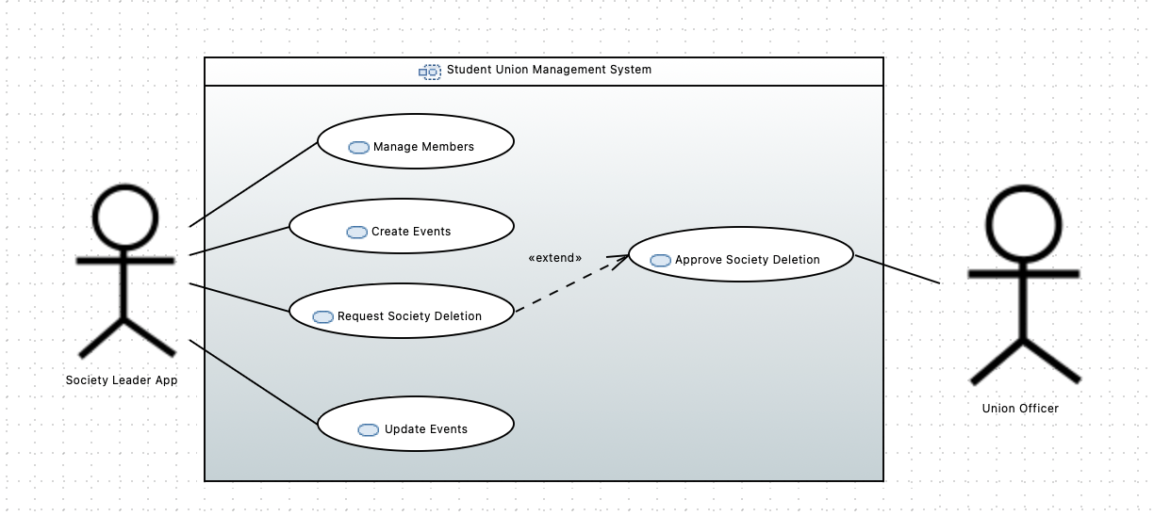
Figure 1 - Case Use Diagram

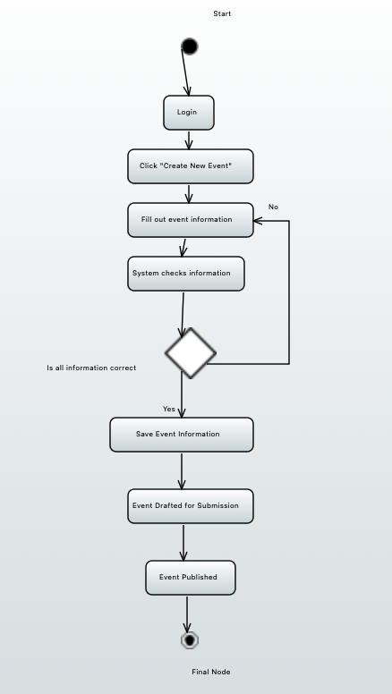
Figure 2 - Activity Diagram

Task 4a:
Task4b:
Task5a:
Task5b:

